COS30019 - Introduction to Artificial Intelligence Tutorial Problems Week 2

Task 1:
Define "AI ethics" and explain how it differs from "responsible AI".
* AI Ethics: a system of moral principles and techniques intended to inform the development and responsible use of artificial intelligence. It focuses on the "What"—identifying the values and standards that AI systems should uphold.
+ Core Pillars: Fairness, transparency, accountability, and privacy.
+ Purpose: To define the boundaries of what is morally acceptable for AI to do in society
* Responsible AI is the practical framework and set of methodologies used to implement AI Ethics in the real world. It focuses on the "How"—the actual steps, tools, and governance a team takes to ensure their AI is safe and ethical.
+ Core Pillars: Engineering practices, bias testing, robust security, and explainability.
+ Purpose: To turn abstract ethical ideas into concrete, repeatable actions within the software development lifecycle.
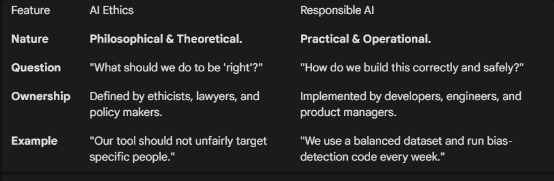

Task 2:
What are the core principles of ethical AI development and deployment? (e.g., fairness, transparency, accountability, privacy)
- Fairness:

Task 3:
How can bias be introduced into an AI system, and what strategies can be used to mitigate it?

Task 4:
Discuss the requirements of Assignment 1 & the strategies to tackle it.

